
CYBERSTER
Internship Program - Batch 2
NetSec Internship - Week 8 Task Report
Network Routing & Switching Concepts
Intern Name: | Muhammad Raza
Instructor Name: | Muhammad Huzaifa Riaz
Company: | CYBERSTER (Batch 2)
Task: | Static vs. Dynamic Networking + Inter-VLAN Routing Lab
Date: | 13 August 2026

Table of Contents

Section
1. Theoretical Analysis - Static vs. Dynamic Networking | 3
1.1 Static vs. Dynamic VLAN Assignment | 3
1.2 Static vs. Dynamic Routing | 4
1.3 When to Use Each - Decision Guide | 5
1.4 Industry Standard Summary | 5
2. Inter-VLAN Routing Lab - Router-on-a-Stick | 6
2.1 Lab Topology | 6
2.2 Layer 2 Configuration - Switch Setup | 6
2.3 Layer 3 Configuration - Router Sub-Interfaces | 7
2.4 End Device IP Configuration | 8
2.5 Connectivity Verification | 9
3. Configuration Summary Checklist | 9
4. Conclusion | 10

1. Theoretical Analysis - Static vs. Dynamic Networking
In enterprise network engineering, the terms "Static" and "Dynamic" are applied to two completely different configuration paradigms: VLAN Assignment at Layer 2 and Network Routing at Layer 3. Understanding the distinction between these approaches, and knowing when to apply each, is a foundational skill for any network engineer.

1.1 Static vs. Dynamic VLAN Assignment
VLAN Assignment determines how an end-device is placed into a specific broadcast domain (VLAN) at the moment it connects to a switch port.
 | Static VLAN (Port-Based) | Dynamic VLAN (MAC / 802.1X-Based)
Concept | The administrator manually assigns a physical switch port to a specific VLAN. Any device plugged into that port is automatically placed in that VLAN regardless of its identity. | The switch port belongs to no VLAN until a device connects. The switch queries a central server (RADIUS/VMPS) that reads the device's MAC address or 802.1X credentials and dynamically assigns the correct VLAN.
Real-World Example | Corporate office: all wall jacks in the accounting department are hardcoded to Switch Ports 1–10, assigned to VLAN 30 (Finance). If an HR printer is plugged in, it instantly joins Finance VLAN regardless of what it is. | Hospital environment: a doctor moves between different wards. Regardless of which ethernet jack they plug into, the authentication server recognises their credentials and dynamically drops the port into the Medical Records VLAN - ensuring access without restricting to a desk.
Administration | Manual configuration per port. Simple to understand and troubleshoot. | Requires RADIUS/VMPS infrastructure. Complex to deploy but fully automated at runtime.
Security | Very secure - port membership is fixed. An unknown device plugged in joins the configured VLAN but gains no special privilege. | Identity-based - extremely granular. A stolen cable plugged into a different port gains nothing without valid credentials.
Scalability | Difficult to scale in large mobile environments - moving devices requires reconfiguring ports. | Scales well in mobile environments - no port reconfiguration needed when users roam.
Use Case | Small-to-medium offices, fixed workstations, printers, servers - environments where users don't move. | Large campuses, hospitals, universities, guest access environments where users roam frequently.
Industry Prevalence | ✓ BY FAR the most common. Used in over 95% of enterprise deployments. | Used in large enterprise / healthcare / education environments with roaming users.

★ Industry Standard: Static VLANs are the dominant choice. They are highly secure, trivial to troubleshoot, require zero additional infrastructure, and are the default configuration method taught in every Cisco certification track (CCNA through CCNP).

1.2 Static vs. Dynamic Routing
Routing determines how a router learns the paths (routes) it should use to forward packets between different IP networks, including routing between VLANs and reaching remote sites.

 | Static Routing | Dynamic Routing (OSPF / EIGRP / BGP)
Concept | The administrator manually types every route into the router's routing table. The router has no awareness of topology changes - if a link fails, traffic is simply dropped until the administrator manually fixes the route. | Routers use specialised protocols to automatically exchange topology information with each other, dynamically build routing tables, and recalculate the best path if a link goes down - without any human intervention.
Real-World Example | Small retail store with one internal network (VLAN 10) and one ISP link. A single static default route (0.0.0.0/0) pointing to the ISP handles all internet traffic simply and cheaply. | Large university campus with 50 buildings and hundreds of VLANs. When a fibre cable is accidentally cut by construction, OSPF detects the failure within seconds and automatically reroutes student traffic through a backup microwave link.
CPU / Memory | Zero overhead - routes are static entries. Ideal for resource-constrained devices. | Consumes CPU for neighbour hello packets, SPF calculations, and route updates. Negligible on modern hardware.
Convergence | No convergence - if a path fails, traffic is lost until a human intervenes. Recovery time: minutes to hours. | Sub-second to 30-second convergence depending on protocol timers. OSPF BFD can detect failures in <1 second.
Scalability | Only viable for small networks (< 5 routers). Every new network segment requires manual route additions on every router. | Scales to thousands of routers. Adding a new network only requires configuring the local device.
Security | No routing protocol traffic - nothing to attack or spoof. Simpler attack surface. | Routing protocol packets can be targets. Mitigated with MD5/SHA authentication between OSPF neighbours.
Typical Usage | Stub networks (one exit point), home labs, ISP default routes, point-to-point WAN links. | Any enterprise with 3+ routers, multiple sites, redundant paths, or dynamic topology.

★ Industry Standard: Dynamic Routing is the absolute standard in enterprise environments. Static routing is reserved for very small networks, stub sites (one exit point), or specific WAN links where simplicity is preferred.

1.3 When to Use Each - Decision Guide
Scenario | Recommended Choice | Reason
Small office, fixed desks, ≤ 50 users | Static VLANs + Static Routing | Simple, no extra infrastructure needed, easy to maintain
Users roam between floors / buildings | Dynamic VLANs (802.1X) + OSPF | Identity follows the user; routing adapts to topology automatically
Single WAN link to ISP (stub network) | Static Default Route | Only one exit — no routing protocol needed, zero overhead
Multi-site enterprise, redundant WAN links | Dynamic Routing (OSPF/EIGRP) | Automatically fails over to backup link; no human intervention required
University, hospital, large campus (roaming users) | Dynamic VLANs + OSPF | Scale demands automation — static config across 100s of ports is unmanageable
Data center servers, fixed IPs, critical infrastructure | Static VLANs + Static/OSPF | Fixed placement is security best practice for servers; routing choice depends on scale
Home lab or small internship network | Static VLANs + Static/ROAS | Simple to learn, identical concepts, no RADIUS server required

1.4 Industry Standard Summary
Concept | Industry Winner | Why
VLAN Assignment Method | Static | Simpler, universally supported, no additional server infrastructure required. The default in every production environment worldwide.
Routing Protocol | Dynamic (OSPF) | Enterprise networks require automatic convergence, fault tolerance, and scalability. OSPF is the most widely deployed enterprise IGP worldwide.

2. Inter-VLAN Routing Lab - Router-on-a-Stick (ROAS)
To practically demonstrate how traffic moves between isolated broadcast domains (VLANs), a Router-on-a-Stick (ROAS) architecture was deployed in Cisco Packet Tracer. ROAS allows multiple VLANs to be routed through a single physical router interface by dividing it into logical sub-interfaces, each handling one VLAN.

2.1 Lab Topology
Device | Role | Interfaces Used
Cisco 1941 Router | ROAS router - performs inter-VLAN routing via sub-interfaces | Gig0/0 (physical), Gig0/0.10 (VLAN 10), Gig0/0.20 (VLAN 20)
Cisco 2960 Switch | Layer 2 switch - segments PC ports into VLANs and trunks to router | Fa0/1 (trunk), Fa0/2 (VLAN 10 access), Fa0/3 (VLAN 20 access)
PC 1 - HR Department | End device in VLAN 10 (192.168.10.10/24) | Fa0 → Switch Fa0/2
PC 2 - IT Department | End device in VLAN 20 (192.168.20.10/24) | Fa0 → Switch Fa0/3

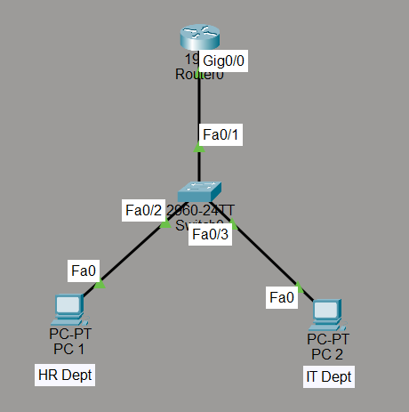
Figure 1: ROAS topology - Cisco 1941 Router connected to 2960 Switch via Gig0/0→Fa0/1 trunk. PC 1 (HR, VLAN 10) on Fa0/2. PC 2 (IT, VLAN 20) on Fa0/3.

2.2 Layer 2 Configuration - Switch Setup
The 2960 Switch requires three configurations: VLAN creation, access port assignment, and trunk port configuration. Without the trunk port on Fa0/1, neither VLAN's tagged traffic can reach the router for routing.

Interface | Mode / VLAN | Purpose
Fa0/2 | Access - VLAN 10 (HR) | Dedicated wired port for PC 1 (HR Dept). Only VLAN 10 untagged frames pass here.
Fa0/3 | Access - VLAN 20 (IT) | Dedicated wired port for PC 2 (IT Dept). Only VLAN 20 untagged frames pass here.
Fa0/1 | Trunk (802.1Q) | Carries both VLAN 10 and VLAN 20 tagged frames on a single cable up to the router. Essential for ROAS.

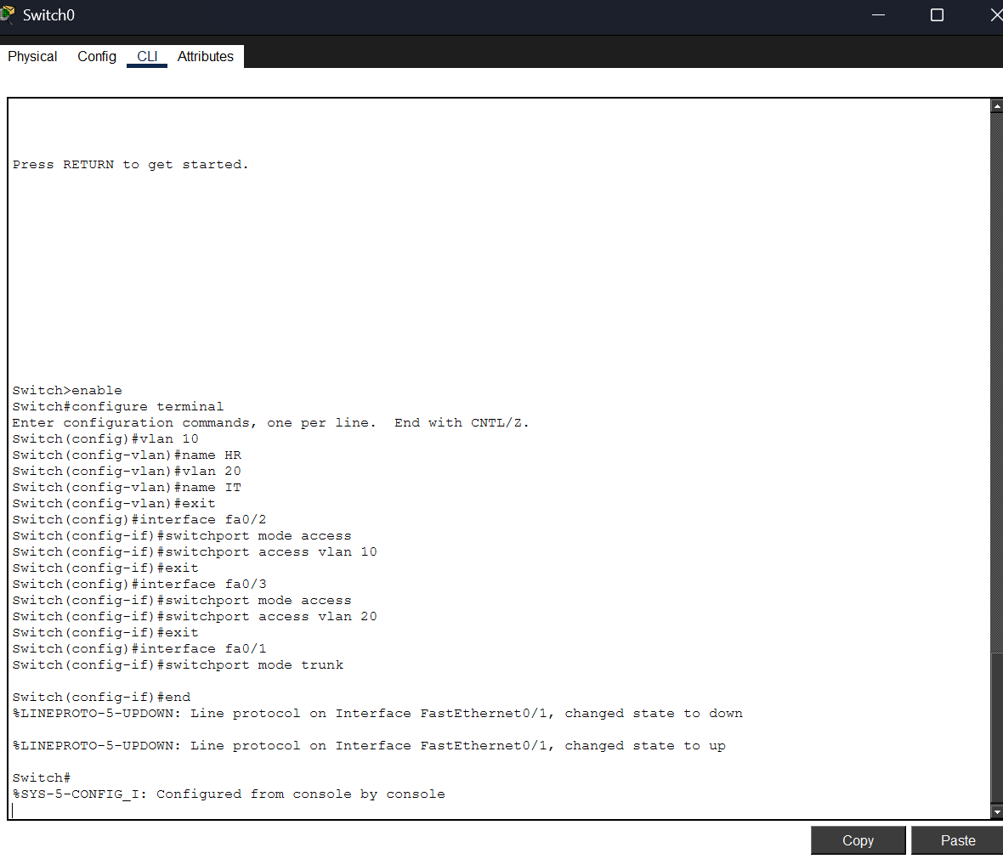
Figure 2: Switch0 CLI - VLAN 10 (HR) created and assigned to Fa0/2; VLAN 20 (IT) created and assigned to Fa0/3; Fa0/1 set to trunk mode. FastEthernet0/1 line protocol confirmed up.

2.3 Layer 3 Configuration - Router Sub-Interfaces
The physical Gig0/0 interface was brought up with no shutdown (no IP address assigned to the physical interface itself - only the sub-interfaces carry IPs). Two logical sub-interfaces were then created:
Sub-Interface | VLAN Tag | 802.1Q Encapsulation | IP Address | Serves As
Gig0/0.10 | VLAN 10 | encapsulation dot1Q 10 | 192.168.10.1 /24 | Default GW - HR Dept
Gig0/0.20 | VLAN 20 | encapsulation dot1Q 20 | 192.168.20.1 /24 | Default GW - IT Dept

When PC 1 (VLAN 10) sends a packet to PC 2 (VLAN 20), it addresses it to its gateway 192.168.10.1 (Gig0/0.10). The router strips the VLAN 10 tag, routes the packet internally, re-encapsulates it with a VLAN 20 tag, and forwards it out Gig0/0.20. The switch receives the tagged frame and delivers it to PC 2 on Fa0/3. This is the complete ROAS packet flow.
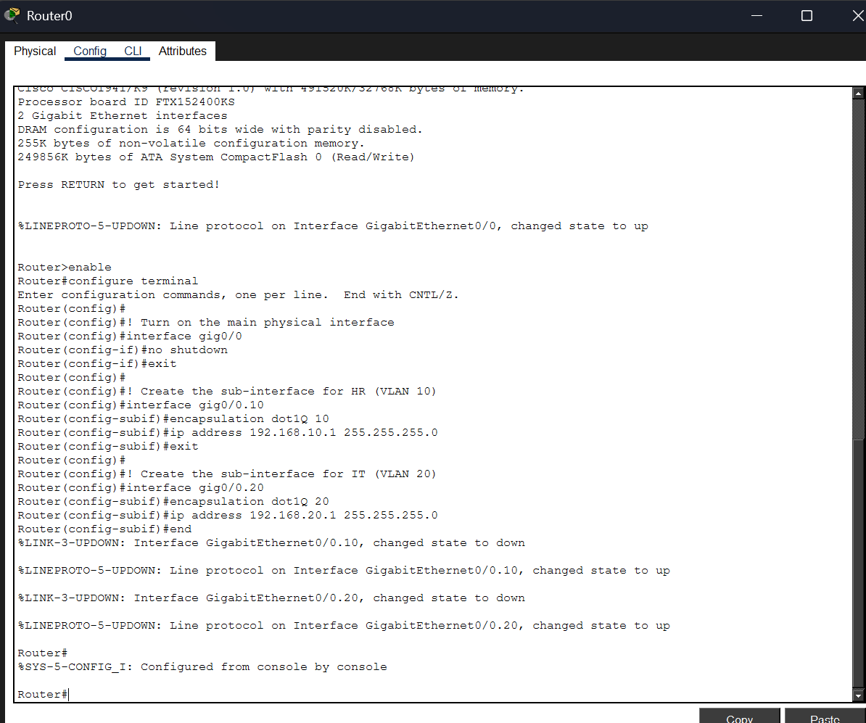
Figure 3: Router0 CLI - Gig0/0 brought up with no shutdown; sub-interface Gig0/0.10 configured with dot1Q 10 encapsulation and IP 192.168.10.1; sub-interface Gig0/0.20 configured with dot1Q 20 and IP 192.168.20.1. Both sub-interfaces confirmed up.

2.4 End Device IP Configuration
Each PC was statically configured with an IP address in its respective departmental subnet. The Default Gateway for each PC is set to its VLAN's router sub-interface IP - this is how the PC knows to forward cross-subnet packets to the router.

Host | VLAN | IPv4 Address | Subnet Mask | Default Gateway
PC 1 - HR Dept | VLAN 10 | 192.168.10.10 | 255.255.255.0 | 192.168.10.1
PC 2 - IT Dept | VLAN 20 | 192.168.20.10 | 255.255.255.0 | 192.168.20.1

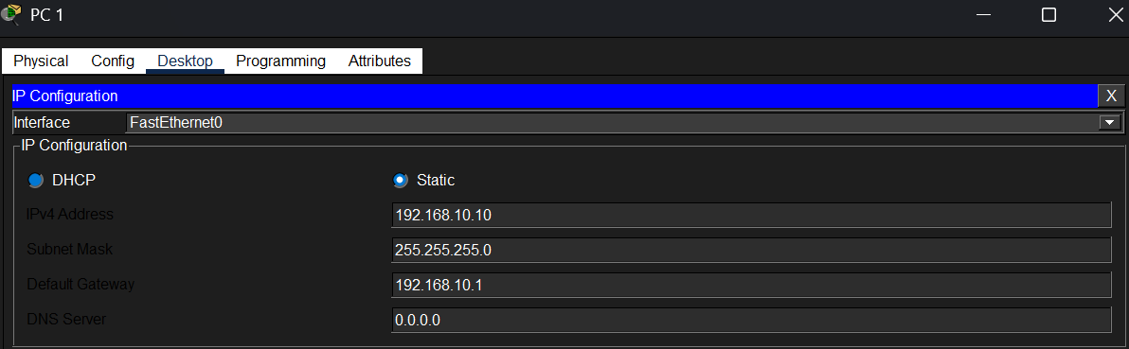  Figure 4a: PC 1 (HR Dept) - Static IP 192.168.10.10/24, Default Gateway 192.168.10.1 (VLAN 10 router sub-interface). | 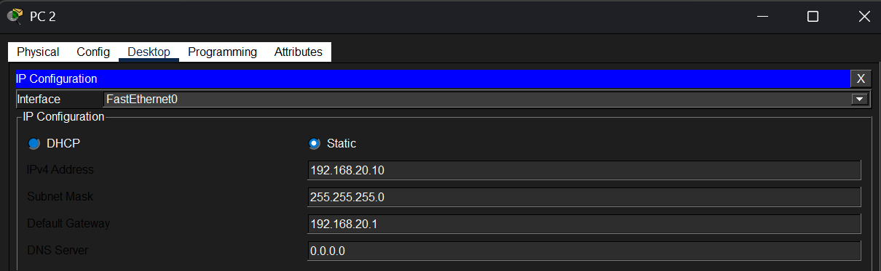  Figure 4b: PC 2 (IT Dept) - Static IP 192.168.20.10/24, Default Gateway 192.168.20.1 (VLAN 20 router sub-interface).

2.5 Connectivity Verification
To verify the ROAS configuration, an ICMP Echo Request (Ping) was initiated from PC 1 (HR Department, VLAN 10) to PC 2 (IT Department, VLAN 20). Without the router, these two VLANs would be completely isolated - this test confirms the router is successfully bridging the broadcast domain boundary.

Traffic Flow Step | Description
Step 1 - ARP | PC 1 sends an ARP broadcast for its gateway 192.168.10.1. The switch tags it VLAN 10 and forwards it up the trunk to the router.
Step 2 - ARP Reply | The router responds with its MAC address. PC 1 now has a Layer 2 path to the gateway.
Step 3 - ICMP to Router | PC 1 sends the ICMP packet. Switch tags it VLAN 10 (via Fa0/2 access port) and forwards it up the Fa0/1 trunk.
Step 4 - ROAS Routing | Router receives the frame on Gig0/0.10, strips the VLAN 10 tag, looks up the routing table, and routes to 192.168.20.0/24.
Step 5 - Delivery to PC 2 | Router re-tags the frame with VLAN 20 and sends it down the trunk. Switch delivers it untagged to PC 2 on Fa0/3.

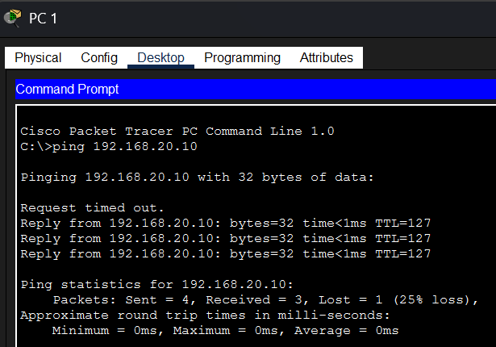
Figure 5: PC 1 pinging PC 2 (192.168.20.10) - 3/4 packets received, 0ms average RTT, TTL=127. First packet lost to ARP resolution (standard behaviour). Inter-VLAN routing confirmed successful.

Source | Destination | Protocol | Result
PC 1 - 192.168.10.10 (VLAN 10) | PC 2 - 192.168.20.10 (VLAN 20) | ICMP (Ping) | ✓ 3/4 - TTL=127, 0ms avg

3. Configuration Summary Checklist
The following checklist confirms every configuration step was completed and verified for the Week 8 lab submission.

✓ | Task | Verification
✓ | Theory — Static vs. Dynamic VLAN: comparison, real-world examples, and use-case guidance documented. | Completed in Section 1.1 with detailed comparison table
✓ | Theory — Static vs. Dynamic Routing: comparison, real-world examples, and industry standard identified. | Completed in Section 1.2 with detailed comparison table
✓ | Decision guide for when to use each approach documented with 7 real enterprise scenarios. | Completed in Section 1.3
✓ | ROAS topology built in Cisco Packet Tracer: 1941 Router + 2960 Switch + 2 PCs. | Figure 1 - topology confirmed up
✓ | Switch configured: VLAN 10 (HR) on Fa0/2, VLAN 20 (IT) on Fa0/3, trunk on Fa0/1. | Figure 2 - Switch CLI confirmed
✓ | Router configured: Gig0/0 brought up, sub-interfaces Gig0/0.10 and Gig0/0.20 with dot1Q encapsulation. | Figure 3 - Router CLI confirmed
✓ | PC 1 (HR): 192.168.10.10/24, GW 192.168.10.1. PC 2 (IT): 192.168.20.10/24, GW 192.168.20.1. | Figures 4a & 4b - IP config confirmed
✓ | Ping from PC 1 (VLAN 10) to PC 2 (VLAN 20) successful - inter-VLAN routing verified. | Figure 5 - 3/4 packets, 0ms, TTL=127

4. Conclusion
Week 8 explored two of the most fundamental design decisions in enterprise networking — how to assign devices to VLANs, and how routers learn paths between networks — and then put those concepts into practice with a live Router-on-a-Stick lab.

Key Takeaways
Static VLANs: The industry default. Port-based assignment is universal, reliable, and requires no additional infrastructure. Every production network uses this as its baseline.
Dynamic VLANs: A powerful identity-based alternative for mobile environments. Requires RADIUS/VMPS infrastructure but enables seamless user roaming across the network.
Static Routing: Best for stub networks and point-to-point WAN links. Simple, zero overhead, but has no fault tolerance - manual intervention required when paths fail.
Dynamic Routing (OSPF): The enterprise standard. Automatically discovers neighbours, shares topology, and converges in seconds after a failure. Non-negotiable for multi-site or redundant networks.
ROAS Lab Result: Successfully demonstrated cross-VLAN communication between HR (VLAN 10) and IT (VLAN 20) using a single router interface divided into sub-interfaces. Ping verified with TTL=127 and 0ms RTT.

The theoretical analysis completed in Part 1 directly explains the practical configuration decisions made in Part 2. Static VLANs were used because the lab represents a fixed-desk office environment. The ROAS technique was chosen over a Layer 3 switch because the Cisco 1941 Router was available and the lab network had only two VLANs - exactly the scenario where a single router interface is the most cost-effective and educationally instructive solution. Together, these concepts form the complete Layer 2-Layer 3 foundation of all enterprise networks covered throughout this CYBERSTER internship programme.

